How to transfer file from PC to Rev Hub wirelessly

Step 1:
Download “SDK Platform Tools” from the below link
https://developer.android.com/tools/releases/platform-tools

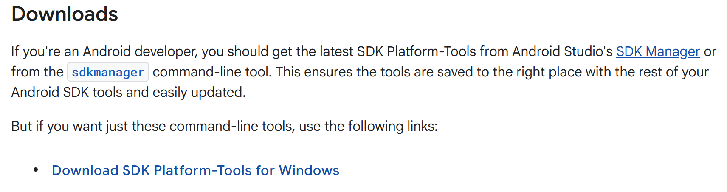

- After downloading, extract the folder in c:\
- Set the path for adb file like below
Open the below window
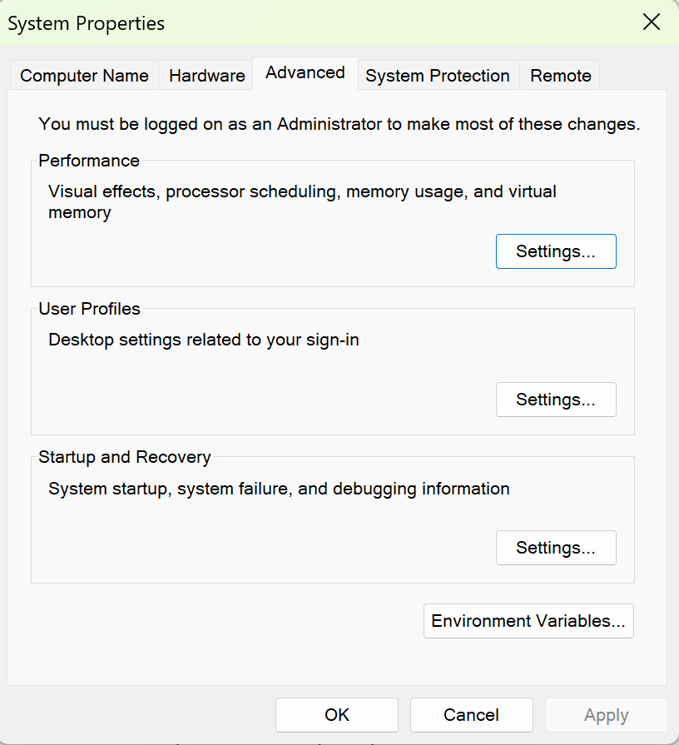
Click on Environment Variables button
The below window opens
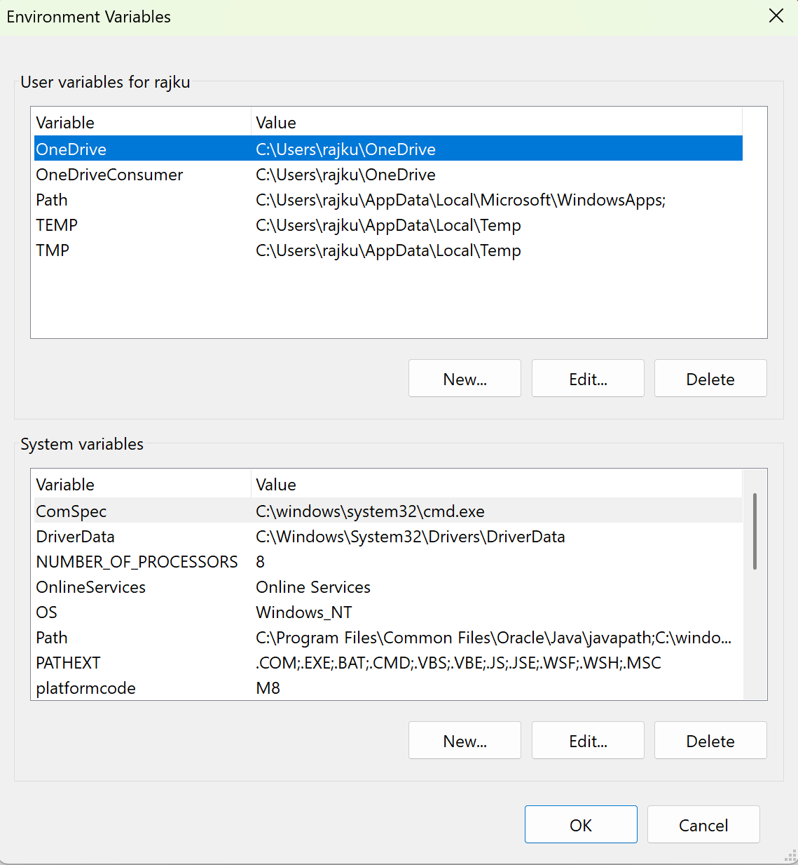

Select path from the above panel and click Edit button
Now add the path like below
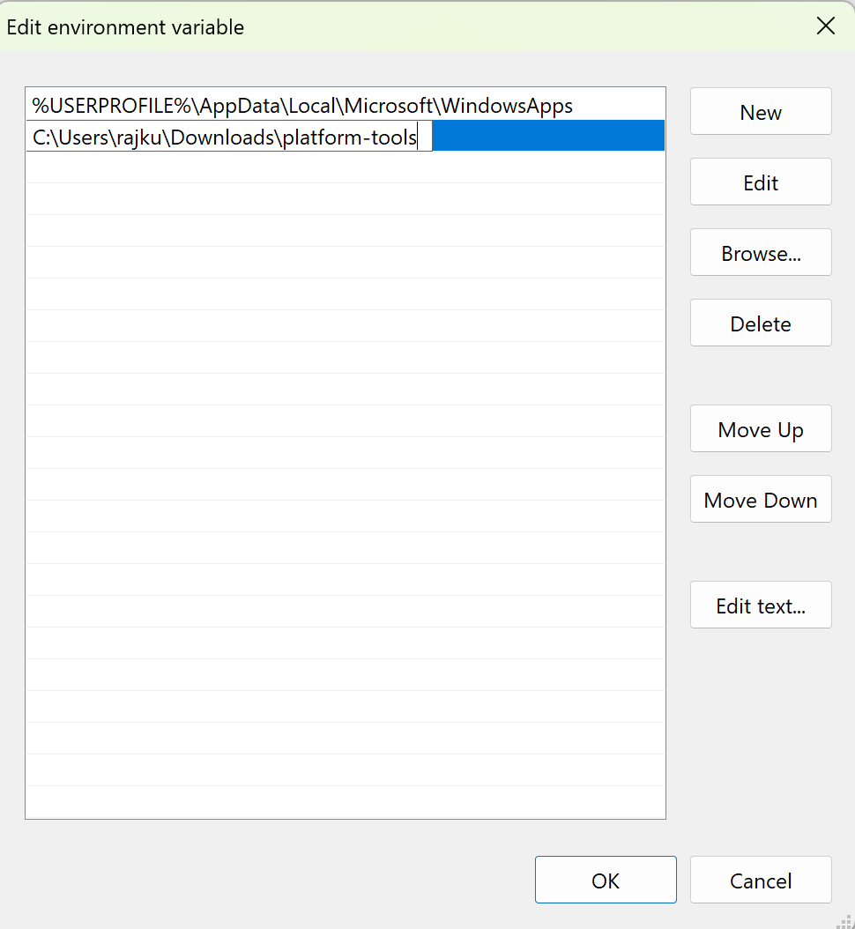
Once the path added just click ok button to close
- if already installed skip step 1

Step 2:

- Create a folder in c: with the name files-to-send
- Copy the files that you want to send inside files-to-send folder
- Create a file in c: with the name send-to-revhub.bat

@echo off
setlocal
title Send Files to REV Control Hub

REM ===== Configuration =====
set "HUB_IP=192.168.43.1:5555"
set "SOURCE=C:\Rajkumar\FTC-2026\files-to-send"
set "DEST=/sdcard/Download/FTC-2026"

REM ===== Find ADB =====
set "ADB=adb.exe"

where adb.exe >nul 2>&1
if errorlevel 1 (
if exist "%LOCALAPPDATA%\Android\Sdk\platform-tools\adb.exe" (
set "ADB=%LOCALAPPDATA%\Android\Sdk\platform-tools\adb.exe"
) else if exist "C:\Android\platform-tools\adb.exe" (
set "ADB=C:\Android\platform-tools\adb.exe"
) else (
echo ERROR: adb.exe not found.
echo Install Android SDK Platform-Tools or edit this BAT file.
pause
exit /b 1
)
)

REM ===== Validate source folder =====
if not exist "%SOURCE%\" (
echo ERROR: Source folder does not exist:
echo %SOURCE%
pause
exit /b 1
)

echo.
echo ========================================
echo Sending files to REV Control Hub
echo ========================================
echo.

REM ===== Connect =====
"%ADB%" connect %HUB_IP%
if errorlevel 1 (
echo ERROR: Could not connect to the Hub.
pause
exit /b 1
)

REM ===== Transfer =====
echo.
echo Copying files...
"%ADB%" push "%SOURCE%\." "%DEST%"

if errorlevel 1 (
echo.
echo ERROR: File transfer failed.
"%ADB%" disconnect %HUB_IP%
pause
exit /b 1
)

REM ===== Disconnect =====
echo.
"%ADB%" disconnect %HUB_IP%

echo.
echo SUCCESS: File transfer completed.
pause

Save and close the file
Double-click send-to-revhub.bat (To run the file)

- Use full commands to send the files manually
Open a Windows Command Prompt and type in “adb.exe connect 192.168.43.1:5555”. This should connect your adb server to the Control Hub over the wireless connection.
adb connect 192.168.43.1:5555
adb devices
adb push "C:\Rajkumar\FTC-2026\myfile.txt" "/sdcard/myfile.txt"
adb disconnect 192.168.43.1:5555

